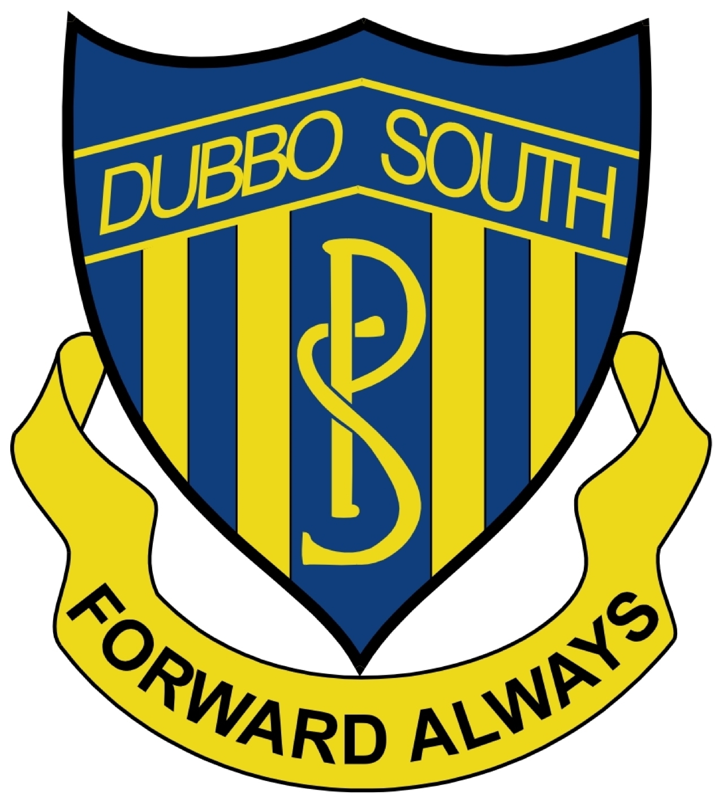
Special Religious Education and Special Education in Ethics Participation Letter

A feature of the public education system in NSW is the opportunity to provide time in class for education in ethics, faith and morality from a religious or non-religious perspective at the choice of parents.
The school website www.dubbosouth-p.schools.nsw.gov.au provides information on these options to support parent/carer choice.
A parent/carer may at any time notify the school in writing that they wish to change their decision. Students will continue the same arrangement as the previous year, unless a parent/carer has requested a change in writing.
For more information about Special Religious Education (SRE) and Special Education in Ethics (SEE), including the list of approved providers, please visit: https://education.nsw.gov.au/teaching-and-learning/curriculum/learning-across-the-curriculum/religion-and-ethics
At this time our school is unable to provide SEE lessons to students.
Students not attending SRE are given supervised alternative meaningful activities.
The following options are available at Dubbo South Public School. Please choose one.
SRE lessons are delivered from a non-denominational booklet based on Christian values and presented by representatives from the Presbyterian and Catholic Churches in Dubbo
OR
Please check this box if you do not wish for your child to attend SRE. Your child will participate in alternative meaningful activities.

Student name: Year:

Signature of parent/carer: Date:

