South%20LogoDubbo South Public School

Fitzroy Street, Dubbo

**Principal:** Ms Sharon Murray **Telephone:** 6882 2529

**Deputy Principal**: Miss Neva Pengilly  **Fax:** 6882 4196

Email: dubbosouth-p.school@det.nsw.edu.au

Welcome to the 2022 school year. In Stage 2 we are looking forward to an engaging and exciting year for children, teachers and parents! Here is some useful introductory information regarding life in Stage 2.

**Stage 2 consists of 7 classes:**

3C Mr McBroom/Mrs Wheeler (Thurs) 3C Miss Jade Clark 3K Mrs McKenzie/ Mrs Starr (Fri) 3/4W Miss Watt 4D Mrs Dickson 4H Mrs Hicks 4T Miss Taylor

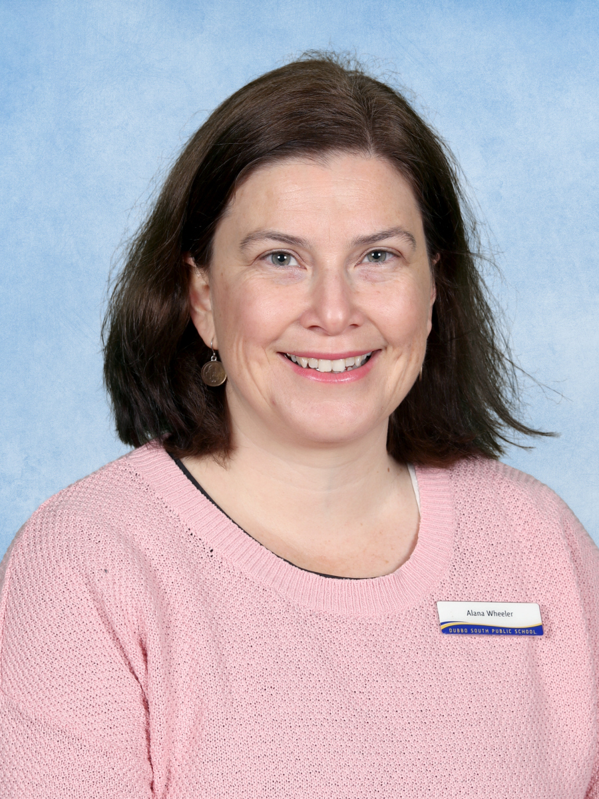

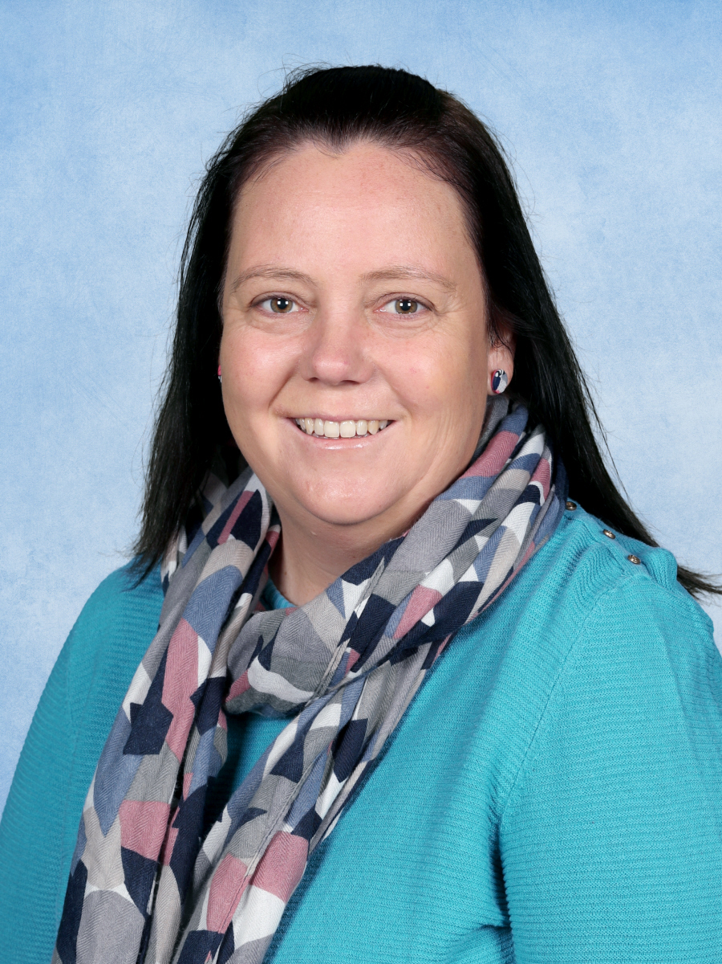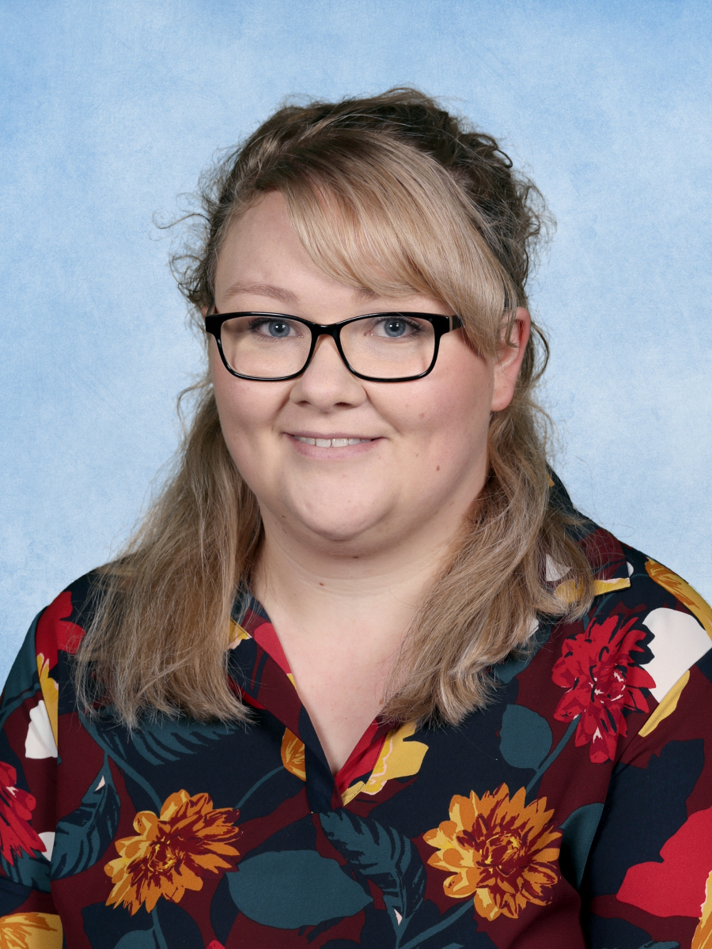

Mr McBroom / Mrs Wheeler Miss Clark Mrs McKenzie/Mrs Starr Miss Watt Mrs Hicks Mrs Dickson Miss Taylor

**Home Reading**

Children are encouraged to read at home on a daily basis. Reading is an integral element of homework and helps to improve fluency, comprehension, vocabulary and literacy skills. Stage 2 students are encouraged to borrow regularly from the school library or use their own books from their home library. Mrs Hosking is introducing the Million Words Challenge in library lessons. Students will track and review books they’ve borrowed from the library, and will receive awards for their progress. These library borrower books are encouraged to be read at home, and returned each week to replace with a new borrowed text.

**Homework**

This year Stage 2 and Stage 3 are trialling online homework tasks using Google Classrooms. Teachers will make these activities available for students to self-pace using a home device (laptop or tablet) and receive feedback as they progress. For families without online access, weekly homework grids will be provided by class teachers.

**Assembly**

Whole school K-6 assemblies will be postponed until COVID restrictions are lifted. Stage 2 assemblies will be held on Friday commencing at 1.45pm Weeks 3, 6 and 9 each term.

**[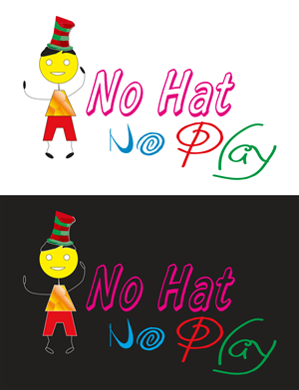](http://www.google.com/url?sa=i&rct=j&q=&esrc=s&source=images&cd=&cad=rja&uact=8&ved=0ahUKEwib74GqnJPSAhVBE5QKHcqKAeIQjRwIBw&url=http://logo.designcrowd.com/contest.aspx?id%3D278572%26page%3D6&bvm=bv.147134024,d.dGo&psig=AFQjCNHWEqBvqKF6xCibTeZjsqVZ7BLIcg&ust=1487286520043125)Hats and water**

The school has a ‘NO HAT, NO PLAY’ policy. Hats must be worn while outside at all times. They are not worn or taken to whole school assemblies, stage meetings, performances or special assemblies. Children are encouraged to bring bottled water to school, especially during the warmer months. Stage 2 no hat area is under the asphalt shelter.

**Sport**

Our primary Swimming Carnival was held last Thursday at the Aquatic Centre. The school Cross-Country will be held in Term 2, and the Athletics Carnival is scheduled for 22nd June 2022. Information about these sporting events will be sent home closer to the events. In Terms 1 & 3, Stage 2 students will be involved in across-stage organised activities at school on Friday mornings. In Terms 2 & 4 Stage 2 students participate in Dubbo primary schools PSSA sport. There will be a cost of $3.50 associated with any bus travel.

**Scripture**

Classes are held in non-denominational groupings once a week for half an hour and are provided by volunteer teachers, with your child’s class teacher present to supervise. Please contact your child’s teacher if you do not wish your child to participate in Scripture lessons.

# **Facebook**

****Facebook is used as a social media platform to share the achievements of our students. For more in depth information, it is important that parents access the Parent Portal regularly for updates and reminders on school events.

**Parent Portal**

Day to day school, stage and class activities are regularly posted on Parent Portal. This is a great way to keep up to date with what’s happening around the school and provides parents with reminders of coming events. Teachers and parents/carers can also send direct messages using this service, and student semesterly report cards are published here for home access. **The Parent Portal is our main communication platform**. If you have not yet signed up or require assistance to get connected, contact our office and they will be able to assist you.

**Maths**

This year we are creating a growth culture in Primary Mathematics. Our approach will allow time to respond to assessment data and accurately identify where students are in their learning journey. We are working together to offer students targeted support and challenges to give them every opportunity to grow in their learning before we move on to new content. Students will benefit from working with different Stage 2 teachers throughout the year.

**RFF- Drama, Music, Library and PD/H/PE**

Stage 2 classes rotate through release lessons on a 2 hour basis each week.

In library, every student will have an opportunity to borrow books. Books can also be changed during lunch time. All children are encouraged to participate in the Premier’s Reading Challenge. The Premier’s Reading Challenge promotes ongoing reading of quality, age appropriate books. Further information about how to participate and complete this fun challenge will be sent out from the library on the newsletter.

**Absence notes**

Please provide explanations for absence to your teacher within 5 school days following all school absence. This explanation should outline the reason your child was absent or it will be recorded as an unexplained on the class roll. Explanations for student absence can now be submitted using your Parent Portal app. Absences due to illness for 3 or more consecutive school days require a medical certificate. It is important for your child to maintain high attendance to achieve their full potential at school.

**‘Fruito’**

During the morning session ‘Fruito’ is eaten to encourage healthy lifestyle habits. Please ensure your child has a piece of fresh fruit each day. It is also a good time to mention we have a number of students in our school community with serious food allergies/anaphylaxis to nuts, eggs and tuna. Please keep peanut butter sandwiches, Nutella, hard boiled eggs or tuna and other food products containing nuts at home.

**Communicating with Teachers**

If you have important information to discuss your child’s teacher please contact them through the Parent Portal or contact the school office to pass on a message. Please note that staff members are engaged in meetings before and after school and are often involved with lesson preparation, administration, organisation and playground duties before, during breaks and after school and it may not be possible to attend to your inquiry immediately. We thank you in advance for your understanding and willingness to be flexible when communicating with our staff.

**[](http://www.google.com/url?sa=i&rct=j&q=&esrc=s&source=images&cd=&cad=rja&uact=8&ved=0ahUKEwjb36jmnpPSAhVGW5QKHcayCooQjRwIBw&url=http://www.bhamgov.org/government/departments/treasury/online_payments.php&bvm=bv.147134024,d.dGo&psig=AFQjCNG1zStkifjOjRoG4-60abw4zrEhXA&ust=1487287213841778)Collection of money**

For your convenience, online payments can be made via the School website www.dubbosouth-p.schools.nsw.edu.au – Make a payment. This payment platform can be used to pay for excursions, bus costs, shows and performances. If you need to send cash payments to school with your child, please put the money in a **sealed envelope** clearly labelled on the front with your **child’s name,** **class** and **what the payment is for.**

**[](http://www.google.com.au/url?sa=i&rct=j&q=&esrc=s&source=images&cd=&cad=rja&uact=8&ved=0ahUKEwiMk-GdopHSAhWIgrwKHS9lBkoQjRwIBw&url=http://www.luesd.k12.ca.us/meadow&bvm=bv.146786187,d.dGo&psig=AFQjCNEbvAFiP5TxPjILAACRRPfjGanCjQ&ust=1487219411586662)Requirements**

All students will need; a pencil case, lead pencils, scissors, glue stick, coloured pencils, pencil sharpener, highlighters, ruler and eraser. Year 3 students will require red and lead pencils daily. Year 4 students will also require blue and red pens, as pen licences will be given to students throughout the year. Book packs containing exercise books for the year are available for purchase from the school office. Some teachers may send books home to be covered. Please return them as quickly as possible.

**MAPPEN Projects**

Stage 2 will be engaging in MAPPEN cross-curricular projects throughout the year to collaboratively problem solve a range of real world tasks to develop a broad range of curriculum, interpersonal and intrinsic skills. This subject area encompasses Science and Technology, History, Geography, STEM projects and the use of a range of digital technologies.

**[](http://www.google.com/url?sa=i&rct=j&q=&esrc=s&source=images&cd=&cad=rja&uact=8&ved=0ahUKEwj54-ujn5PSAhUEU7wKHb-TAVoQjRwIBw&url=http://www.clipartpanda.com/categories/free-clip-art-school-kids&bvm=bv.147134024,d.dGo&psig=AFQjCNG-nSEPqn9c9dTYeOdUJqdHD_f6DQ&ust=1487287273922112)Excursion**

In Term 3, Stage 2 will be participating in an overnight excursion to Wambangalang Environmental Education Centre to support our History, Geography and Environmental Education units. Plans are being finalised and notes will be sent home later this term which will outline dates and costs.

We are looking forward to an exciting and productive year of learning in Stage 2. We greatly appreciate your support and partnership in working together to provide a positive school experience for all our learners.

Mr McBroom

Stage 2 Leader