South%20LogoDubbo South Public School

Fitzroy Street

# Dubbo

Principal: Ms Sharon Murray Telephone: 6882 2529

Deputy Principal: Miss Neva Pengilly Fax: 6882 4196

Email: [dubbosouth-p.school@det.nsw.edu.au](mailto:dubbosouth-p.school@det.nsw.edu.au)

Welcome to the 2022 school year. In Stage 3 we are looking forward to an engaging and exciting year for children, teachers and parents. Here is some useful introductory information regarding life in Stage 3.

**Stage 3 consists of 6 Stage classes:**

5C Sally Constable 5M Zoe McCathie 5W Carissa Walmsley/Briony Bird

6L Lisa Lunn 6K Patrice Kent 6H Louise Heaslip

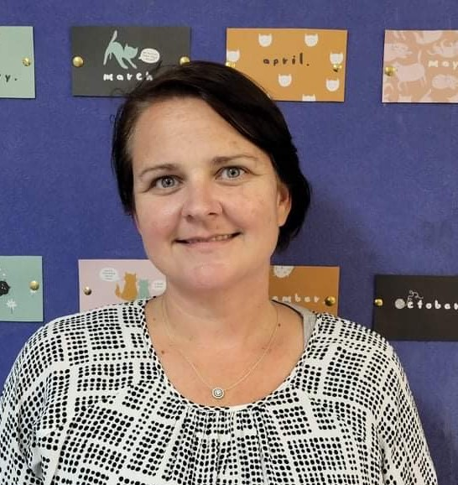

Sally Constable Zoe McCathie Carissa Walmsley/Briony Bird Lisa Lunn Patrice Kent Louise Heaslip

**Maths**

This year we are creating a growth culture in primary Mathematics.Our approach will allow time to respond to assessment data and accurately identify where students are in their learning journey. Weareworking together to offer students targeted support and challenge to give them every opportunity to grow in their learning before we move on to new content. Students will benefit from working with different Stage 3 teachers throughout the year.

**Home Reading**

Children are encouraged to read on a daily basis. Regular home reading is a fantastic waytosupportyourchild’svocabularydevelopment,wordaccuracy,comprehensionandreadingfluency,so it’simportantforbookchoicestobe appropriate.EachStage3classroomhasalargecollectionofbooks thatareavailableforborrowingeachday.

**School Magazine**

The P & C has kindly purchased another subscription to ‘The School Magazine’ for each student at our school. Students will be issued with a new magazine each month. These magazines will be used at school and then brought home to share with families. We hope to foster a love of reading and engage our families and community in this process also.

**Homework**

Each child will be given a weekly homework grid on Monday. Homework is collected each Friday and will be marked and returned to the students by Tuesday, the following week. This year there will also be homework tasks accessible through Google Classrooms. These tasks provide immediate feedback to students and allow them to select their level of difficulty. Whilst paper homework will still be distributed weekly, we strongly encourage students to take advantage of the online resources.

[](https://www.google.com.au/url?sa=i&rct=j&q=&esrc=s&source=images&cd=&cad=rja&uact=8&ved=0ahUKEwiIrpLempHSAhVHbbwKHcAVCnwQjRwIBw&url=https://www.pinterest.com/jrdreher4/sports-clip-art/&bvm=bv.146786187,d.dGo&psig=AFQjCNEHLm82b9npBE_jFrSiW-i99hNZDg&ust=1487217401789618)**Sport**

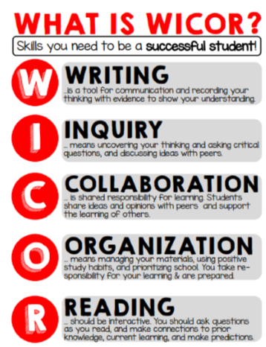The primary Swimming Carnival was held in Week 1. Cross-Country and the Athletics Carnival will be held in Term 2. In Terms 1 & 3 students will be involved in Stage organised activities at school. In Terms 2 & 4 students participate in Dubbo primary schools PSSA sport. There will be a cost of $3.50 associated with any bus travel.

**Assemblies**

Whole school K-6 assemblies will be postponed until COVID restrictions are lifted. Stage 3 assembly will be held on the Mondays of Weeks 3, 6 & 9. SRC meetings are held Week 5 and 10 of every term.

**Inquiry Based Learning and WICOR**

At Dubbo South Public School, we value critical and creative thinking. We aim to develop confident, independent problem solvers, learners and thinkers who are secondary school ready and motivated to continue their education. Across all Stage 3 rooms students use WICOR strategies and Inquiry Based Learning in order to guide students in comprehending concepts and articulating ideas at increasingly complex levels.

**Scripture**

Classes are held in non-denominational groupings once a week for half an hour and are provided by the Ministers Fraternity. Please inform your child’s teacher in writing or email if you do not wish them to participate in Scripture.

**‘Fruito’**

During the morning session ‘Fruito’ is eaten to encourage healthy lifestyle habits. Please ensure your child has a piece of raw fresh fruit or vegetable each day. It is also a good time to mention we have a number of students in our school community with serious food allergies/anaphylaxis to nuts, eggs and tuna so please save peanut butter sandwiches, hard boiled eggs or tuna and other food products containing nuts to enjoy at home, rather than at school.

**Excursion**

Stage 3 students will have the opportunity to participate in a day excursion during Term 1 to Wambangalang learning centre. Students will engage in team building, initiatives and critical and creative thinking activities. Notes will be distributed in Week 2.

[](https://www.google.com.au/url?sa=i&rct=j&q=&esrc=s&source=images&cd=&cad=rja&uact=8&ved=0ahUKEwjUzJ7onJHSAhUSPrwKHYaXAwsQjRwIBw&url=https://www.dreamstime.com/photos-images/school-excursion.html&bvm=bv.146786187,d.dGo&psig=AFQjCNHpOXEopp3EaM8vBxKaOoX5bDrC3Q&ust=1487217877071804)The major excursion this year is to Sydney for 3 days and 2 nights – letters will be issued to students later in the term regarding dates and costing.

**Child Protection**

This is a **mandatory** section of the Personal Development Program and will be covered in PDHPE by the classroom teachers. All students will participate in these important lessons.

**Absentee Notes**

Pleasesendanotetoyourteacherwithin5schooldaysfollowingaschoolabsence.Thisnoteshouldoutlinethereasonyourchildwasabsentoritwillberecordedasanunexplainedabsenceon theclassroll.An absentee note can now be accessed and submitted through the school’s Parent Portal.Absencesduetoillnessfor3ormoreconsecutiveschooldaysrequireadoctor’s certificate.Itisimportantforyourchildtomaintainhighattendanceto achievetheirfullpotential at school.Occasionalabsencescanbeunavoidableduetoillnessorcircumstance,however10ormoreabsencesduringasemester(withoutapprovalfromthePrincipal)isconsidered unsatisfactory.

**Collection of Money**

[](https://www.google.com.au/url?sa=i&rct=j&q=&esrc=s&source=images&cd=&cad=rja&uact=8&ved=0ahUKEwj2yeSHnZHSAhUDxbwKHa-MD8UQjRwIBw&url=https://clipartfest.com/categories/view/4824b3b32f6b060117d2b2d94bfaca2e71ce0adb/electronic-payment-clipart.html&bvm=bv.146786187,d.dGo&psig=AFQjCNEe-NhxHXbAC833EEhUuPcw_kT1KQ&ust=1487218020839450)When sending money to school with your child to pay for shows, excursions, PSSA sport etc, please put the money in a sealed envelope with your child’s name and class clearly marked, as well as what activity the payment is for. An online payment option is now available through the schools website *www.dubbosouth-p.schools.nsw.edu.au*.

**Requirements**

Allstudentsneed; **a pencil case, lead pencils, blue pens, red pen, scissors, glue stick, coloured pencils, pencil sharpener, textas, highlighters, ruler and eraser.** A USB drive may also be useful (no larger than 8Gb). Book packs are available from the school office at the cost of $7.50.Students areexpectedtofollowtheStage3bookcode,treatingtheirbooks respectfully,keepingbookworktidyandfreefromgraffiti.

**Appointment with Teachers**

3 way conferences will be conducted early Term 2. If you have important information to relay to your child’s teacher before then, please send a message through the Parent Portal so a mutually convenient time can be arranged. Stage 3 Assistant Principal, Lisa Lunn can be contacted via the school office. Please note, staff members are engaged in meetings before and after school and are often involved with lesson preparation, administration, organisation and playground duties before, during and after school and it may not be possible to attend to your inquiry immediately. We thank you in advance for your understanding and willingness to be flexible when requesting appointments.

# **Facebook**

Facebook is used as a social media platform to share the achievements of our students. For more in depth information, it is important that parents access the Parent Portal regularly for updates and reminders on school events.

**School parent portal**

Please join the school parent portal to communicate with your child’s teacher. This is the only teacher/parent communication that will be used throughout 2021 and it also offers many other exciting access opportunities such as early access to online reports during Term 2 & 4.

Lisa Lunn

Stage 3 Leader